

Theories of Architecture & Urbanism [ARC 610303]

Project: The Image of the City
Part 2: Cognitive Mapping & Illustrated Essay
Name: Tang Kar Jun
ID: 0314075
Tutor: Ms Ida Marlina Mazlan
Site: Little India (Brickfields) Kuala Lumpur.

Little India or Brickfields is a town situated just outside the city centre of Kuala Lumpur. It was given such a name due to its amount of population as well as business. Little India is a busy street and is easily recognizable from its vibrant decorations. Here, you will find many Indian shops, cultures and even lifestyle and would make a great place of study. They are also famous for their Indian delicacies and many of such restaurants can be found in Little India. This place has served as a tourist attraction site as well due to its bustling lifestyle and culture.
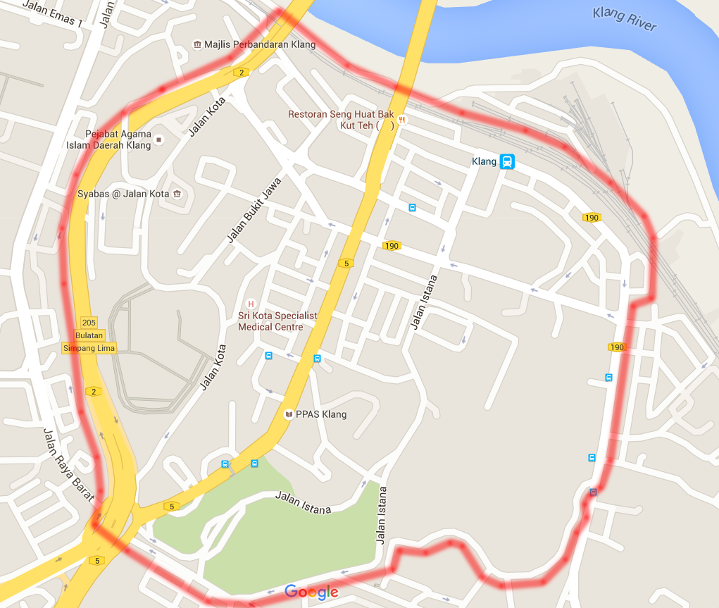
Figure 1: Actual map of Little India showing site boundary (Google.com, 2015).
Little India is a site which is full of interesting historical backgrounds and has been moulded since our ancestors to what it is now. The site used to be the main depot for the Keretapi Tanah Melayu (KTM) during the rule of British here in Malaysia. The British brought men over from Sri Lanka as work labour to construct the railway. Those men are the Indians that forged the current Indian community on site. As such, Little India has been a place which has expanded exponentially from a residential to a commercial and functional extension of downtown Kuala Lumpur.
Due to its growth into a working city, Little India can be researched based on Kevin Lynch’s notions of imageability and how it influenced the people’s perception of the city. For this research, I’ve used Lynch’s concept on The Image of the City which explains that people perceive cities through certain physical elements. These elements are defined as paths, edges, districts, nodes and landmarks.
Based on Kevin Lynch’s theory on The Image of the City & Imageability, the paths are the networks in which the user habitually, occasionally or perhaps travel on. These paths are used frequently due to the roads it connects to the urban context. Looking at Little India, there are major pathways which show its significance. In addition to that, the pathway for both human and vehicular movement shows how busy the Little India street is. 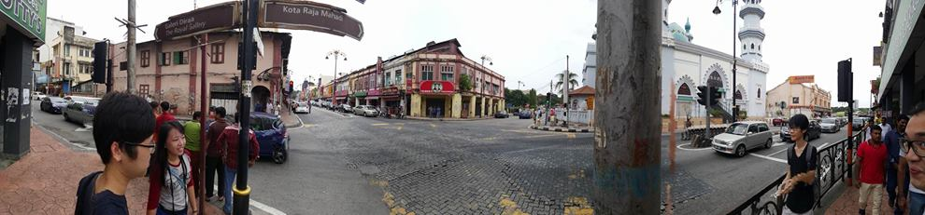
Figure 2 –Jalan Tengku Kelana, Klang
The image above shows the main street of Little India where many occurrences can be found there. While the image may not show a busy street as it was taken on a weekend, I assure you that this city street is extremely busy. Being Little India’s centre street, many of the landmarks can also be noted here such as the Masjid India Klang and as well as the newly built Mydin at the far end of the road. Along this road are the commercial districts whereby the Indian community sell off their many items. Jalan Tengku Kelana is Little India’s most vibrant and busy pathway with inconsistent building height and shape.
In Little India, therein exists other pathways which shows prominent characteristics which are exclusive to the path itself. For example, Jalan Istana is a pathway filled with greenery and then the Istana is camouflage within the nature.
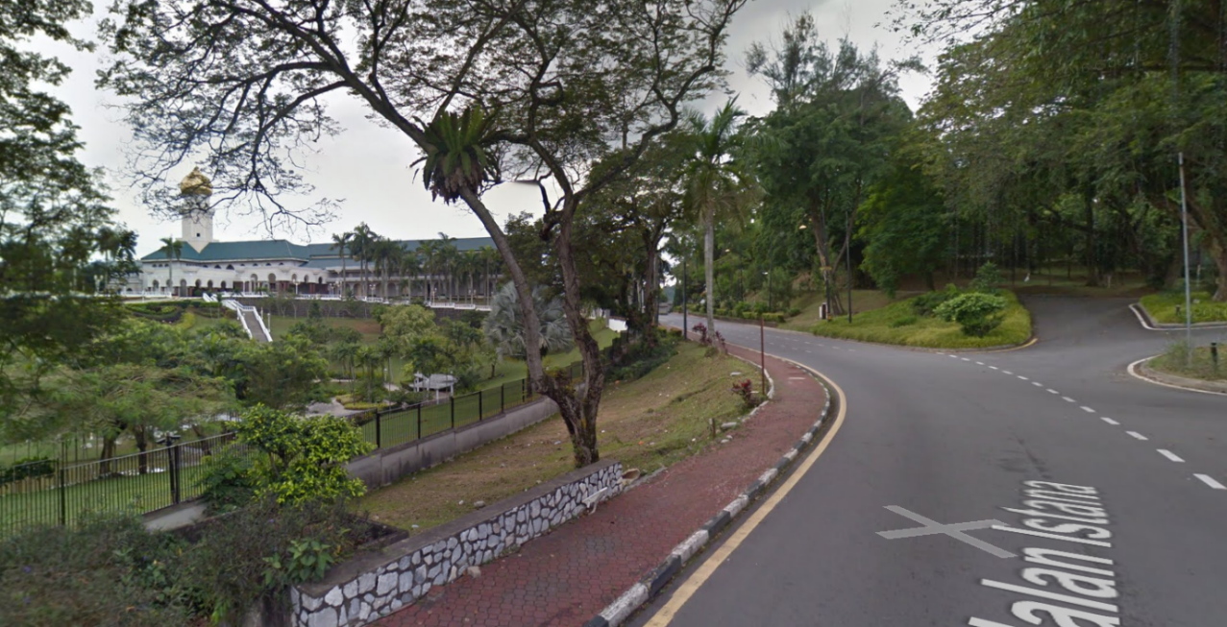
Figure 3 – Istana Alam Shah
There is also Jalan Mohet which house the more advanced communal building on both sides of its street. This has separated this pathway as one where it serves a commercial function. There are service buildings which range from travelling agencies to hospitals which helps the community here in maintaining a productive lifestyle.
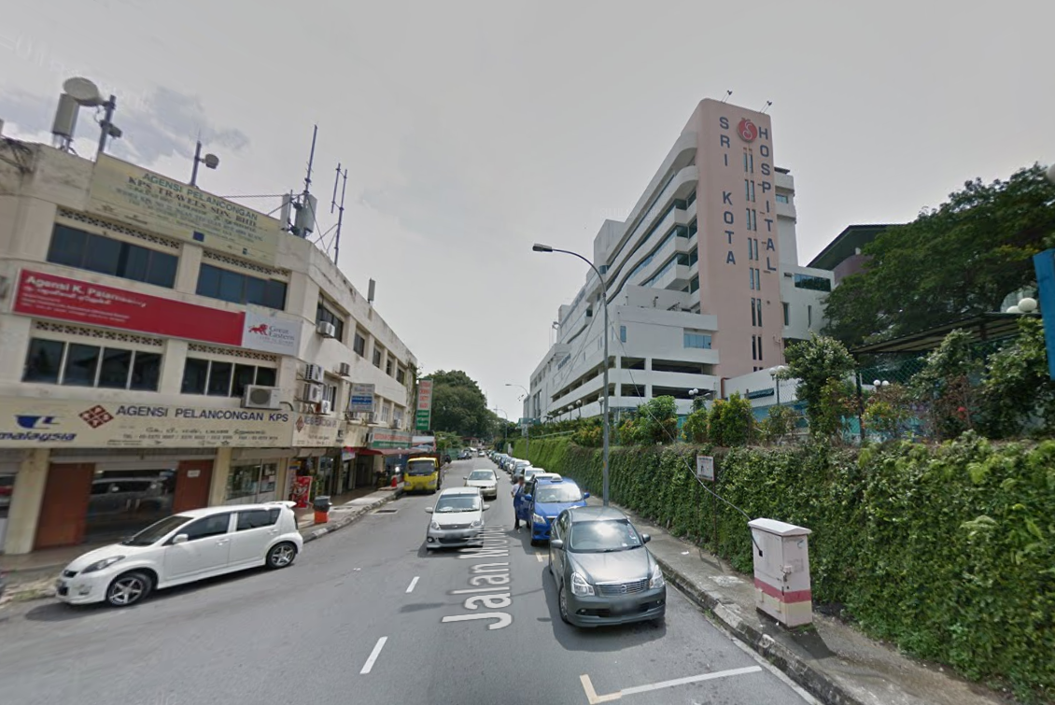
Figure 4 – Jalan Mohet
Clear paths that have strong identities will be able to bring a city together. According to Lynch’s theory, if the qualities shown are consistent along the line, the path will be imaged as a continuous, unified element.
Next, the edges are linear elements which make up a boundary between two areas. Edges are usually pathways but they are not necessarily one. Edges can take form from all sorts of pathways depending on its function.
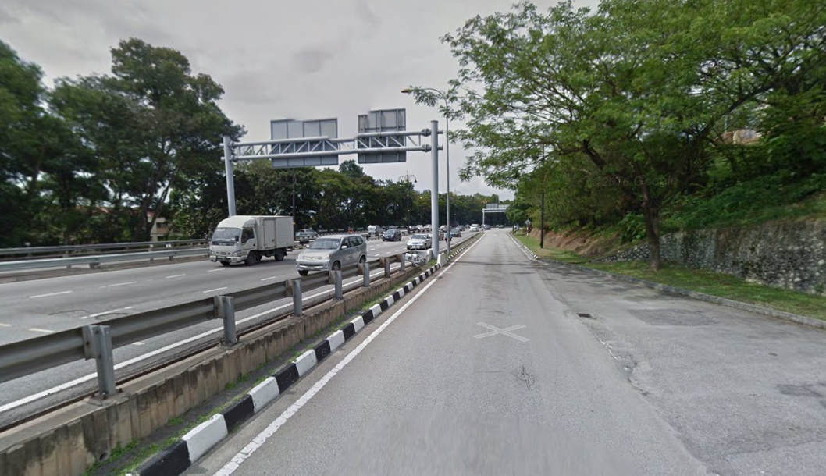
Figure 5 – Highway as an edge
Take the above image as reference, that is an intangible edge which separates the highway and our site boundary. It is due to the difference in the road functions which separates the two roads. In Little India, there are also roads from the depots used back then which has been converted into our KL Sentral Stations. The railway tracks for those type of transport also covers the right side of our site boundary and therefore makes up an edge to the site. The tracks are also covered by fences to protect from any accidents and makes an edge very bold. There are also authority edges in which an authority area forms a borderline which separates Jalan Klang from the community districts. This sort of edges may be hard to discover as only a handful of building in the district serve as community service. In Little India, the communal service district actually divides the business districts and authority districts. A different kind of edge is Jalan Istana which has lush greenery to split itself from the regular housing districts.
In Little India, there are districts where the area is really distinguished from the other districts. Districts are large city areas which has a common point whereby the user can point out the distinguished characteristics.
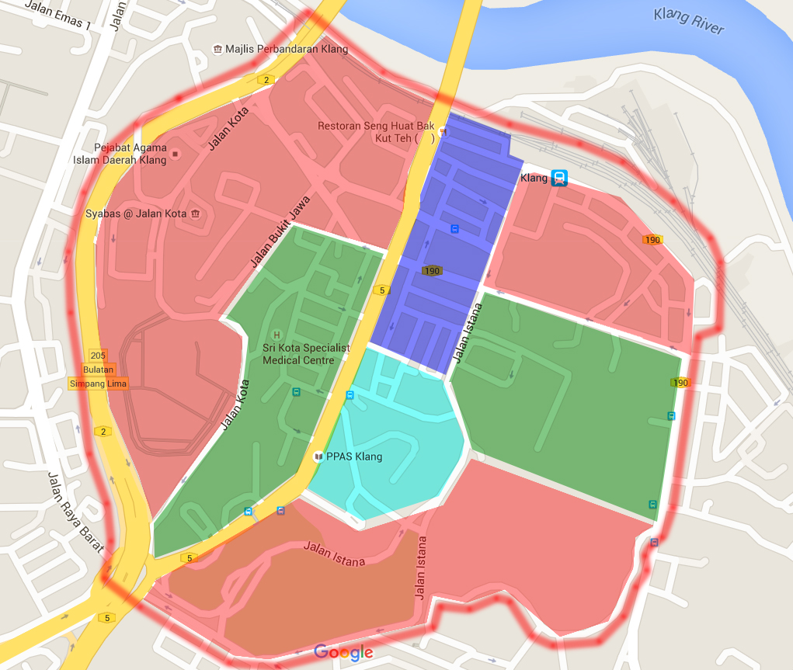
Figure 6 – Colour mapping of districts
In the above map, there are four colours which divides Little India into four different districts and each having their respective buildings which separates them from other districts. Starting off with the red coloured districts are the authority districts which larger in scale occupies a major plot of land. As the name implies, the places in this district serve to act out authority issues regarding its community. A few examples of buildings in this district are Syabas at Jalan Kota, Mahkamah Seksyen Klang, Balai Bomba as well as those which help to uphold righteousness and justice in the area. Moving on to the green district are the communal service district. Here, a majority of public buildings can be found such as schools, hospitals and the lot. The buildings here also stand out as it requires a big size to accommodate the many people in Little India. The cyan colour district stands out for being a residential commodity and are clustered within the district. The buildings here existed since old times and therefore has been designed lavishly. Moving from this district is the blue colour district which represents the business area. Mainly occupied with rows of shop houses which are different in building sizes. A majority of these shops also make up the nodes of Little India.
Regarding the previous statement, nodes are the strategic focus in a junction or pathway. Being a node in that location must call out the shops’ prominence or even a node for a road constantly having traffic. A node is defined characteristically and is not limited to only shop houses but can also represent road nodes and human nodes. Take Little India’s Jalan Tengku Kelana as an example, the road itself has a few node points whereby the junctions intersect with each other. On top of that, there are also schools located around it.
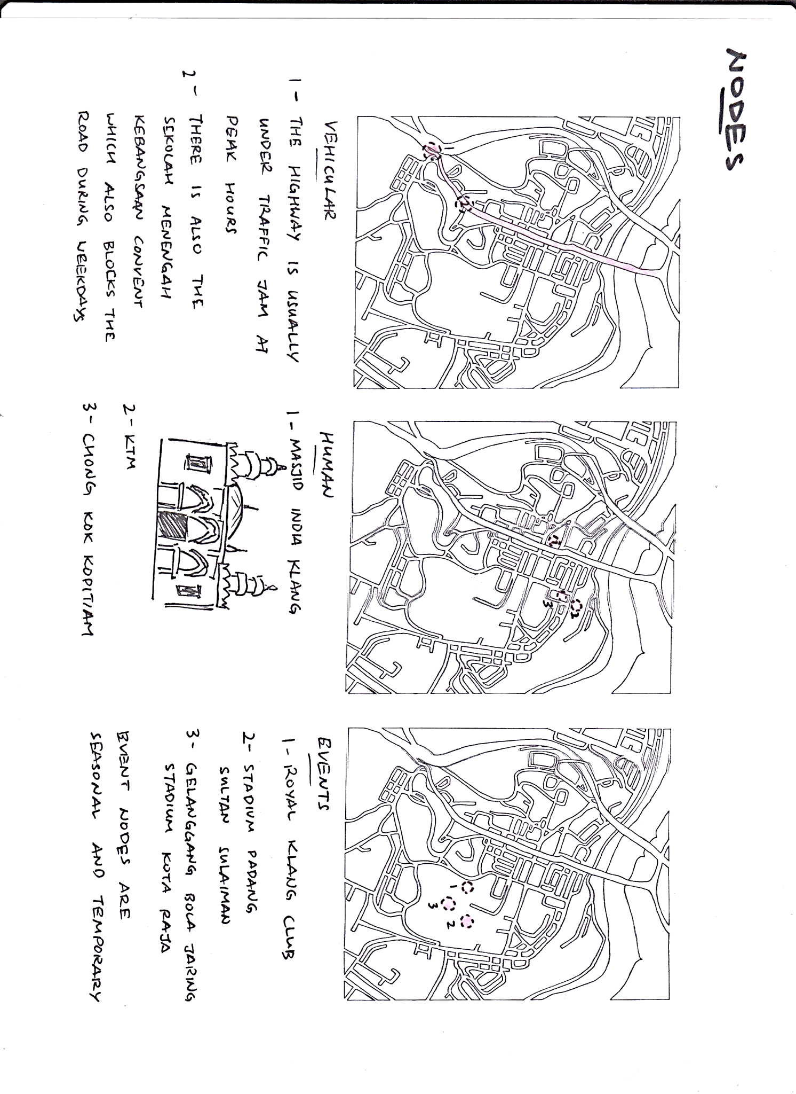
Figure 7 - Nodes
By looking at the above image, Little India is identified to have around three major nodes which is classified into vehicular nodes, human nodes and event nodes. Vehicular nodes in Little India point towards the traffic jam at peak hours of the day which include the opening of a school session and the ending of it where there will be an overload of vehicles. Then there is the Masjid India Klang which the worshippers would frequent to pray at. The KTM is also one such human node whereby they take the train to and from other locations. Lastly we have event nodes which are seasonal and temporary. The few example would be the Royal Klang Club and the Stadium Padang Sultan Sulaiman. There is also a race circuit for miniature race car models which is an event exclusive to Little India’s community.
In little India, there are buildings which are really significant and are considered to any observer to be a referral point. These landmarks are what makes a location really unique as it distances itself as a singularity in a spatial location. In Little India, the landmarks stand out as it contrasts from the surrounding buildings.
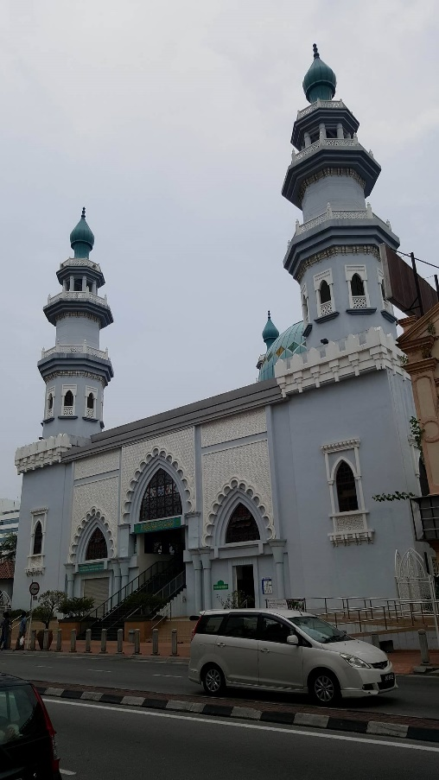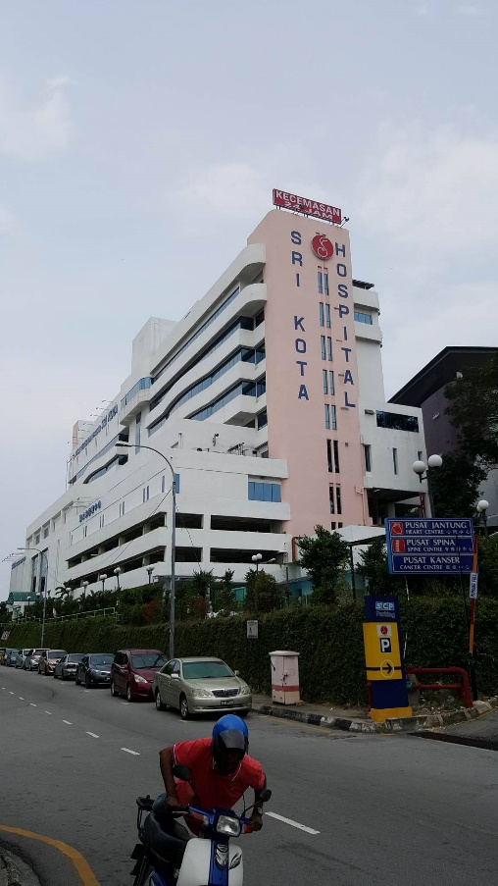
Figure 8 – Masjid India Klang Figure 9 – Hospital Sri Kota
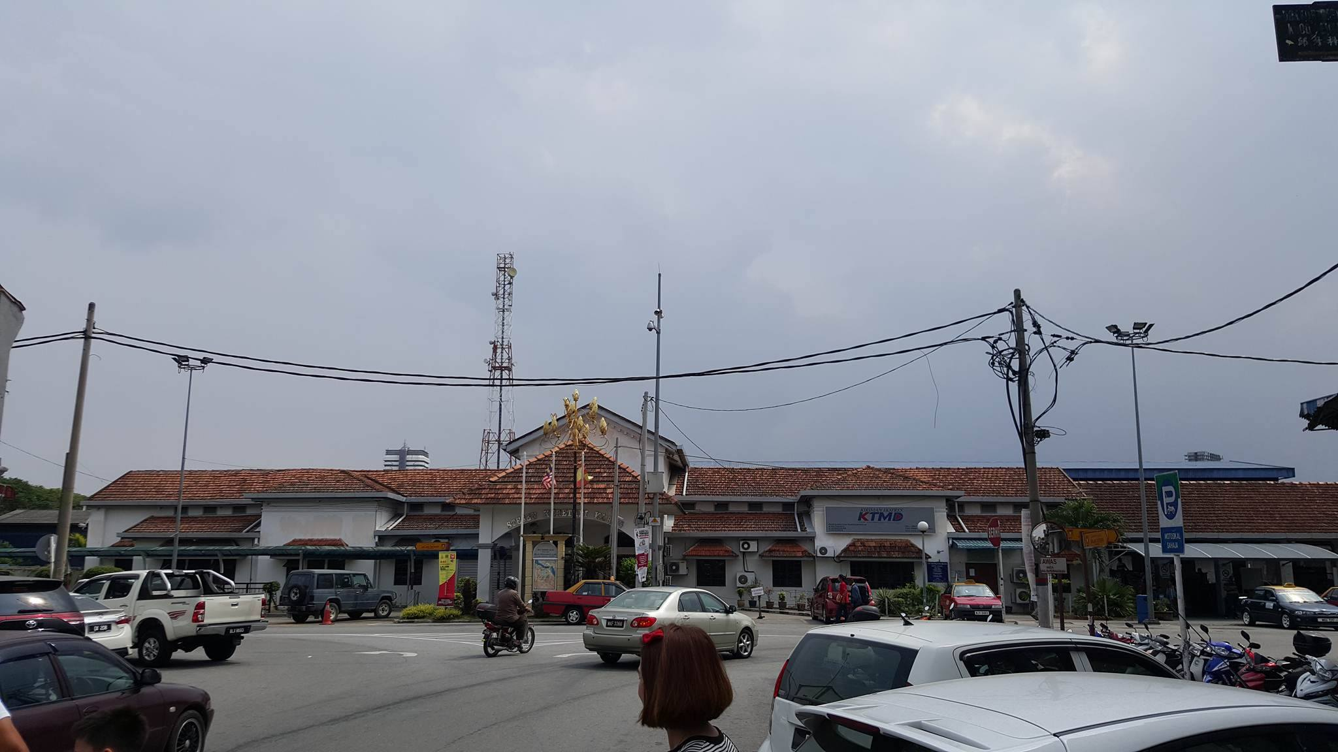
Figure 10 - KTM

