

**Building Science 2 [BLD 61303]**

Project 2: Design Studio Integration

**Tutor:** Ar. Edwin Yean

Tang Kar Jun 0314075

TABLE OF CONTENT PAGE

1. Introduction
   1. Objective
   2. Project Description
   3. Floor Plans
2. Lighting
   1. Daylight (Atrium space)
   2. Artificial Light (Private Study Room)
   3. PSALI (Public Reading Space)
3. Acoustic
   1. External Noise
   2. Reverberation Time (Multipurpose Hall)
   3. Transmission Loss (PC Lab)

4.0 References

1. INTRODUCTION
   1. Objectives

This project aims to integrate the lighting and acoustics principles into the context of the final design studio 5 project. This enables students to better understand the relation of their design to real life situations. It encompasses the lighting issues and noise management and is retaliated with design spaces.

* 1. Project Description

The Community Library is built with the concept “Knowledge” in mind. The design is heavily affected by the library book shelves which seems to spiral upwards. The building is built with a double façade to help curb both lighting issues and acoustic problems. The façade also serves as an attraction point to draw in pedestrians to the site.

By using knowledge, the building serves to empower the citizens with more knowledge. By making the entire building a library, the users will also travel through all the spaces and interact with more people.

* 1. Floor Plans

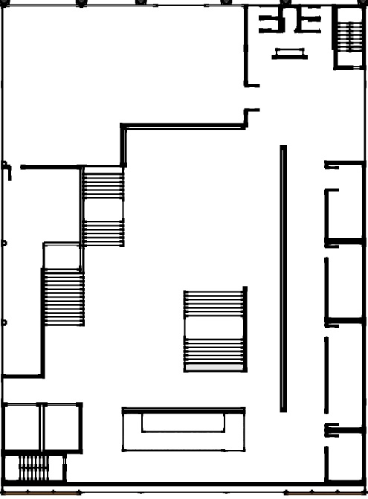

Ground Floor Plan

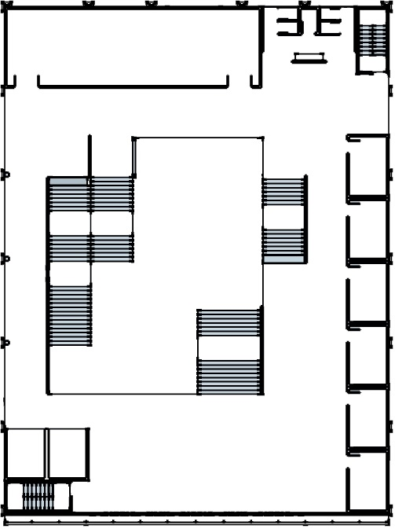

1st Floor Plan

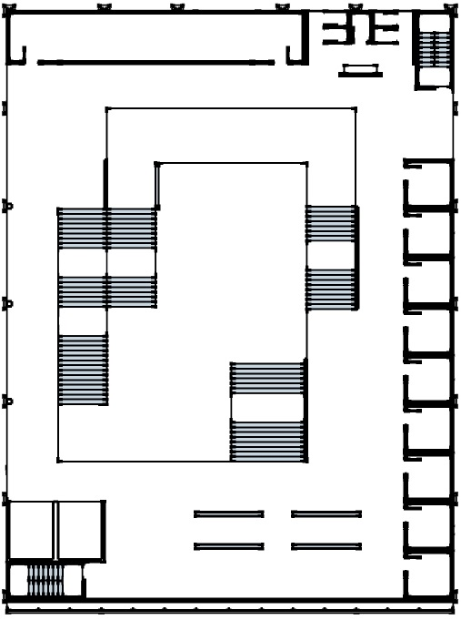

2nd Floor Plan

1. LIGHTING
   1. Daylight (Atrium Space)

According to MS 1525, Daylight factor distribution is as below:

Daylight Factor, DF

|  |  |
| --- | --- |
| DF, % | Distribution |
| >6 | Very bright with thermal & glare problem |
| 3~6 | Bright |
| 1~3 | Average |
| 0~1 | Dark |

The selected space is the void which forms the atrium space which is located at every floor with different height. This space receives daylight from the clerestory roof. The ground floor is also exposed to sunlight which makes the space having minimum artificial lighting.

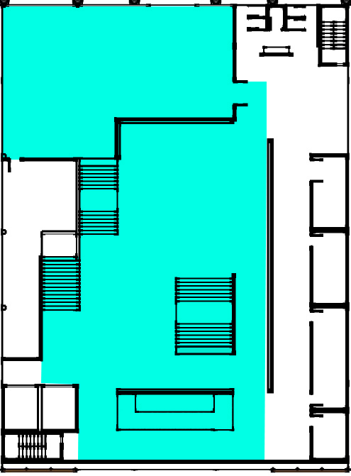

Ground floor

Daylight Factor Calculation

|  |  |
| --- | --- |
| Floor area (m2) | 1011.86 |
| Area of façade exposed to sunlight | 685.01 |
| Area of skylight (m2) | 0 |
| Exposed façade & skylight area to floor area ratio/Daylight Factor, DF | (685.01+0) / 1011.86  =0.67  =100% x 0.67  =6.7% |

Natural Illumination Calculation

|  |  |
| --- | --- |
| Illuminance | Example |
| 120000 lux | Brightest sunlight |
| 110000 lux | Bright sunlight |
| 20000 lux | Shade illuminated by sunlight |
| 1000~2000 lux | Overcast day, midday |
| <200 lux | Extreme dark clouds, midday |
| 400 lux | Sunrise/Sunset on a clear day |
| 40 lux | Full overcast, sunset/sunrise |
| <1 lux | Extreme dark clouds, sunset/sunrise |

E external = 20000 lux

DF = E internal / E external x 100

E external = 10 x 20000 / 100

= 2000 lux

Conclusion

The atrium space has a daylight factor of 6.7% and natural illumination of 2000 lux. This will result in thermal and glare problems. Therefore, the glass on the clerestory roof and the ground floor entrances will be changed to double-glazed low e-value glass as a proposal. The double façade design will also further reduce the amount of sunlight exposure.

* 1. Artificial Lighting (Private Study Room)

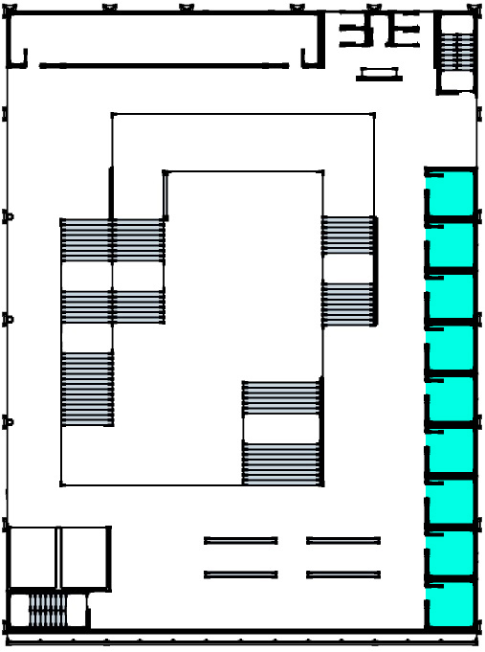

Private study rooms (2nd floor)

Based on MS 1525, the minimum lighting level for a study room is at 300lux.

Type of lighting used:

|  |  |
| --- | --- |
| Type of fixture | LED Downlight |
| Type of light bulb | C:\Users\User\AppData\Local\Microsoft\Windows\INetCache\Content.Word\COMF3293-CLP-global-001.png |
| Material of fixture | Aluminium |
| Type | DN571B (deep recessed version) |
| Median useful life | 25000 hours |
| Power | 36 |
| CRI | 80 |
| Colour temperature (K) | 3000 |
| Color | Warm white |
| Lumen | 4000 |

Lumen Method Calculation

|  |  |
| --- | --- |
| Location of lighting | Private study rooms on 2nd floor |
| Dimensions | Length = 3m  Width = 3m  Height of Ceiling = 3m |
| Floor area (A) | 3m x 3m = 9m2 |
| Lumen (lux) | 3000 Lm |
| Height of work level | 0.8 |
| Height of luminaire (m) | 2.8 |
| Mounting height (Hm) | 2.5 |
| Reflection factors | Ceiling = 0.7  Wall = 0.5  Floor = 0.2 |
| Room index / RI (K) | =0.6 |
| Utilisation factor (UF) | 0.5 |
| Maintenance factor (MF) | 0.8 |
| Standard illuminance given by MS1525 | 300 |
| Number of lights needed |  |
| Spacing to Height Ratio (SHR) |  |
| Fitting layout (m) | Fittings required along a 3m wall, 3/1.725 = 1.74  = 2 rows  Hence, approximately 2 x 3 = 6 luminaires required  Spacing along 3m wall  3/2 rows  =1.5m  Half spacing = 0.75m |

Fitting layout

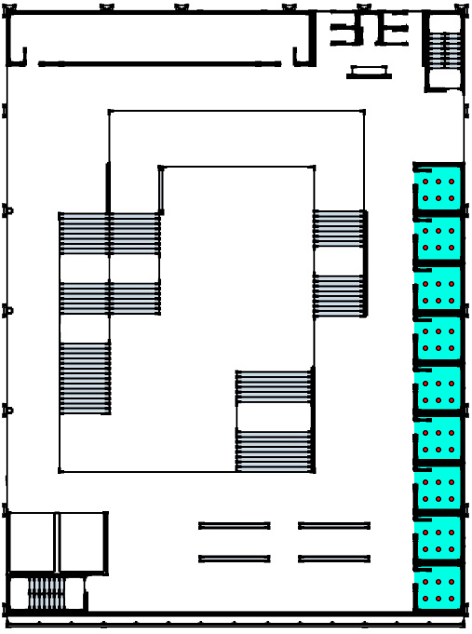

Conclusion

6 LED downlights are used to illuminate a single private study room to achieve a minimum of 300lux in regards to MS1525. With good lighting, users can do their work and study in a well-lit environment.

* 1. PSALI (Public Reading Space)

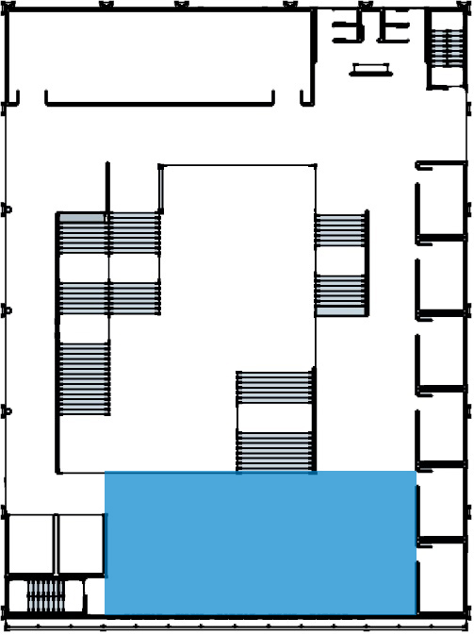

Public Reading Space (1st floor)

Based on MS 1525, the minimum lighting level for a reading space is at 300lux.

Type of lighting used:

|  |  |
| --- | --- |
| Type of fixture | LED Downlight |
| Type of light bulb | C:\Users\User\Downloads\LP_CF_ST420B_EU-CLP-en_EG-001.jpg |
| Material of fixture | Aluminium |
| Type | ST422B (adjustable version) |
| Median useful life | 50000 hours |
| Power | 40 |
| CRI | 80 |
| Colour temperature (K) | 3000 |
| Color | Warm white |
| Lumen | 5000 |

Lumen Method Calculation

|  |  |
| --- | --- |
| Location of lighting | Public reading space on 1st floor |
| Dimensions | Length = 8.5m  Width = 18.5m  Height of Ceiling = 3m |
| Floor area (A) | 8.5m x 18.5m = 157.25m2 |
| Lumen (lux) | 5000 Lm |
| Height of work level | 0.8 |
| Height of luminaire (m) | 2.8 |
| Mounting height (Hm) | 2.5 |
| Reflection factors | Ceiling = 0.7  Wall = 0.5  Floor = 0.2 |
| Room index / RI (K) | =2.37 |
| Utilisation factor (UF) | 0.5 |
| Maintenance factor (MF) | 0.8 |
| Standard illuminance given by MS1525 | 300 |
| Number of lights needed |  |
| Spacing to Height Ratio (SHR) |  |
| Fitting layout (m) | Fittings required along a 18.5m wall, 18.5/2.55 = 7.25  = 8 rows  Hence, 24 luminaires required / 8 rows  =3 rows  Spacing along 8.5m wall  8.5/3 rows  =2.83m  Half spacing = 1.42m |

Fitting layout

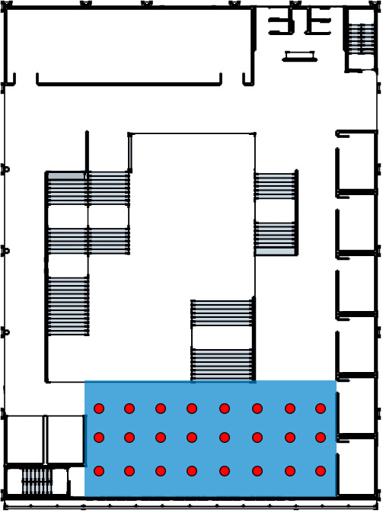

Conclusion

The public reading space requires 24 downlights to ensure a minimal 300lux based on MS1525. The lights can be switched on or off based on different time of the day as it also receives sunlight from the windows.

1. ACOUSTIC

3.1External Noise

It is mandatory whereby External Noise Sound Pressure Level (SPL):

|  |  |  |
| --- | --- | --- |
| Type of noise | Traffic noise | Activity noise |
| Hour of recording | Peak hour | Peak hour |
| Readings (Approximately) | 30 dB | 70 dB |
| Sound intensity |  |  |
| Total intensity |  | |
| Sound pressure level | dB | |

The external noise has a combined SPL of 70dB which originated from the traffic flow as well as the noisy activities going on in site. The sound pressure level of 70dB travels into the library during peak hours. However, this value is obtained occasionally as the site is usually dormant but gets noisy when there are activities going on.

Based on the Acoustic Standard ANSI, a library must have an average SPL value of in between 35dB to 40dB. Because the site generates a lot of noise, few solution are introduced to reduce the noise such as using acoustic panels and having noise barrier.

3.2 Reverberation Time (Multipurpose Hall)

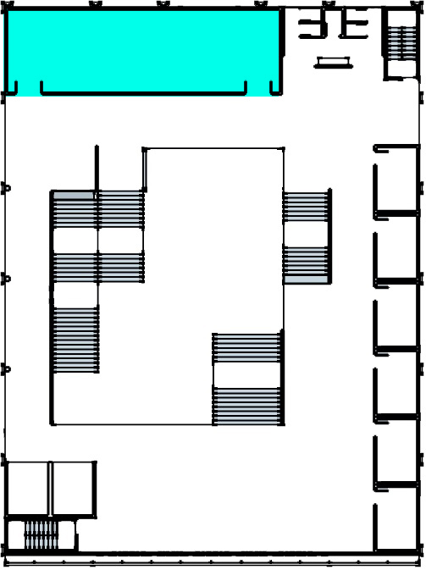

Multipurpose hall on 1st floor

Room height: 3m

Standard reverberation time for archive room: 0.4s

Peak hours capacity: Max. of 150 people

Volume of the hall: 5.5m x 18m x 3m = 297m3

Reverberation time for 500Hz at non-peak hours with 50 people

|  |  |  |  |  |
| --- | --- | --- | --- | --- |
| Building component | Material | Area, S/m2 | Absorption coefficient, a | Sound absorption, Sa |
| Wall | Concrete | 125.2 | 0.02 | 2.504 |
| Wall | Glass | 5.6 | 0.1 | 0.56 |
| Floor | Concrete strain | 99 | 0.06 | 5.94 |
| Ceiling | Plaster | 99 | 0.015 | 1.485 |
| Door | Plywood | 10.2 | 0.17 | 1.734 |
| Chairs | Leather-covered | 65 | 0.5 | 32.5 |
| People |  | 50 | 0.46 | 23 |
| Total absorption, A | | | | 67.723 |

Reverberation time, RT = (0.16 x V) / A

= (0.16 x 297) / 67.723

= 0.7s

The reverberation time for the multipurpose hall should be at an average of 1.2s to 1.8s according to Acoustic Standard ANSI. Because, the result is lower, it will cause the sound levels too low at a distance and make the sound “dry”. To help boost the sound in the huge multipurpose hall, audio equipment such as loudspeaker and microphone may be used.

Reverberation time for 2000Hz at peak hours with 150 people

|  |  |  |  |  |
| --- | --- | --- | --- | --- |
| Building component | Material | Area, S/m2 | Absorption coefficient, a | Sound absorption, Sa |
| Wall | Concrete | 125.2 | 0.05 | 6.26 |
| Wall | Glass | 5.6 | 0.1 | 0.56 |
| Floor | Concrete strain | 99 | 0.02 | 1.98 |
| Ceiling | Plaster | 99 | 0.04 | 3.96 |
| Door | Plywood | 10.2 | 0.24 | 2.448 |
| Chairs | Leather-covered | 65 | 0.61 | 39.65 |
| People |  | 150 | 0.51 | 76.5 |
| Total absorption, A | | | | 131.358 |

Reverberation time, RT = (0.16 x V) / A

= (0.16 x 297) / 131.358

= 0.4s

Based on 2000Hz, the reverberation time for the multipurpose hall should be at an average of 0.8s to 1.4s according to Acoustic Standard ANSI. The result is the same as the above and needs help boost from audio equipment such as loudspeaker and microphone.

3.2 Sound Reverberation Index (PC Lab)

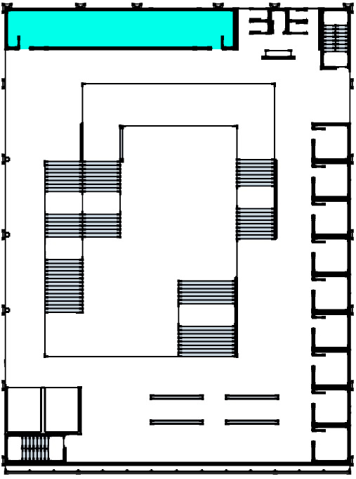

|  |  |  |  |  |
| --- | --- | --- | --- | --- |
| Building element | Material | Area, m2 | SRI, dB | Transmission coefficient, T |
| Wall | Glass panel | 48 | 26 | 2.51 x 10-3 |
| Door | Glass panel | 6 | 26 | 2.51 x 10-3 |
| Total | - | 54 | - | 5.02 x 10-3 |

Tav = (5.02 x 10-3 / 54)

= 9.3 x 10-5

SRIoverall =

= 40.32 dB

Conclusion

Through the calculations above, 40 dB of noise level is reduced when travelling from the PC lab to the foyer spaces. Assuming the sound pressure level of a PC lab is at 60dB, the emitted sound is at 20dB. This amount falls under the low noise environment and is a suitable place for people to study under.

1. References

# 1. LuxSpace, recessed. (n.d.). Retrieved June 20, 2016, from <http://www.lighting.philips.com/main/prof/indoor-luminaires/downlights/luxspace/luxspace-recessed>

# 2. ExactEffect Mini, recessed. (n.d.). Retrieved June 20, 2016, from <http://www.lighting.philips.com.eg/prof/indoor-luminaires/downlights/exacteffect-mini-recessed>

# 3. Room Illumination Level. (n.d.). Retrieved June 20, 2016, from <http://www.pioneerlighting.com/new/pdfs/IESLuxLevel.pdf>

# 4. About reverberation time. (n.d.). Retrieved June 20, 2016, from <http://www.bksv.com/Applications/RoomAcoustics/about-reverberation-time>

# 5. An Approach to Improve Acoustic performance. (n.d.). Retrieved June 20, 2016, from <http://www.jofamericanscience.org/journals/am-sci/am1003s/002_23443am1003s14_9_15.pdf>