

Theories of Architecture & Urbanism [ARC 610303]

Project: The Image of the City
Part 2: Cognitive Mapping & Illustrated Essay
Name: Tang Kar Jun
ID: 0314075
Tutor: Ms Ida Marlina Mazlan
Site: Little India (Brickfields) Kuala Lumpur.

1.0 Introduction of Site
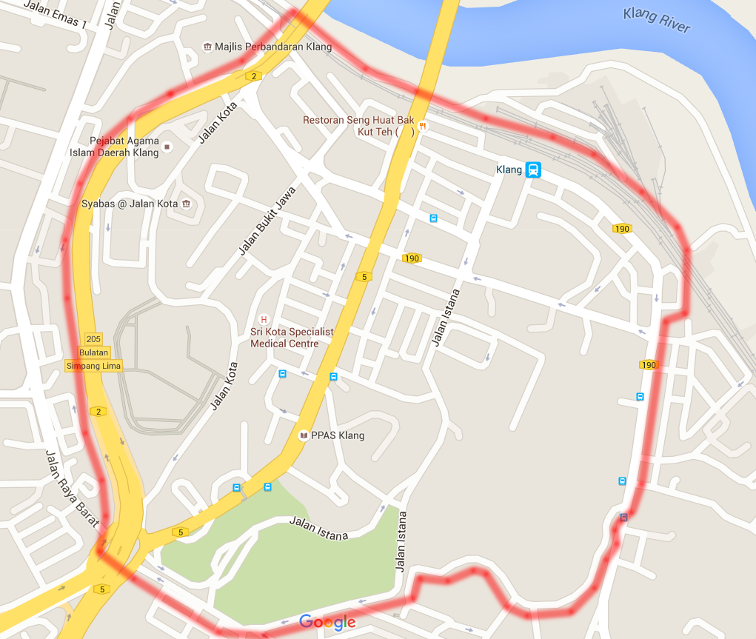
Figure 1: Actual map of Little India showing site boundary (Google.com, 2015).
Little India or Brickfields is a town situated just outside the city centre of Kuala Lumpur. It was given such a name due to its amount of population as well as business. Little India is a busy street and is easily recognizable from its vibrant decorations. Here, you will find many Indian shops, cultures and even lifestyle and would make a great place of study. They are also famous for their Indian delicacies and many of such restaurants can be found in Little India. This place has served as a tourist attraction site as well due to its bustling lifestyle and culture.
Little India is a site which is full of interesting historical backgrounds and has been moulded since our ancestors to what it is now. The site used to be the main depot for the Keretapi Tanah Melayu (KTM) during the rule of British here in Malaysia. The British brought men over from Sri Lanka as work labour to construct the railway. Those men are the Indians that forged the current Indian community on site. As such, Little India has been a place which has expanded exponentially from a residential to a commercial and functional extension of downtown Kuala Lumpur.
Due to its growth into a working city, Little India can be researched based on Kevin Lynch’s notions of imageability and how it influenced the people’s perception of the city. For this research, I’ve used Lynch’s concept on The Image of the City which explains that people perceive cities through certain physical elements. These elements are defined as paths, edges, districts, nodes and landmarks.

  - Introduction of Cognitive Mapping
Cognitive mapping is a mental representation of a physical location where an individual remembers the approximate visualisation of a certain space. According to Kevin Lynch’s Image of the City, 1960, sketches of maps can reveal the human’s knowledge of a large scale complex environment.
The environment map consists of the five mentioned; paths, edges, districts, nodes and landmarks. The cognitive map is drawn from visuals and perception senses; visual, smell, noise which leaves an impression as one travel a place. As such, a cognitive map is more defined when a person has a better memory of a place.
Cognitive also involves any landmarks which serves as a guide for mental image. This leaves a great impression of a person and can be used to give directions. By standing in a corner and just focus on the surroundings, one can actually identify a lot of cognitive information.
The cognitive mapping is drawn after our site visits. As mentioned, every map differs from another due to the memory and perception of the site. Photos are also taken as a form of evidence to back up the given information.
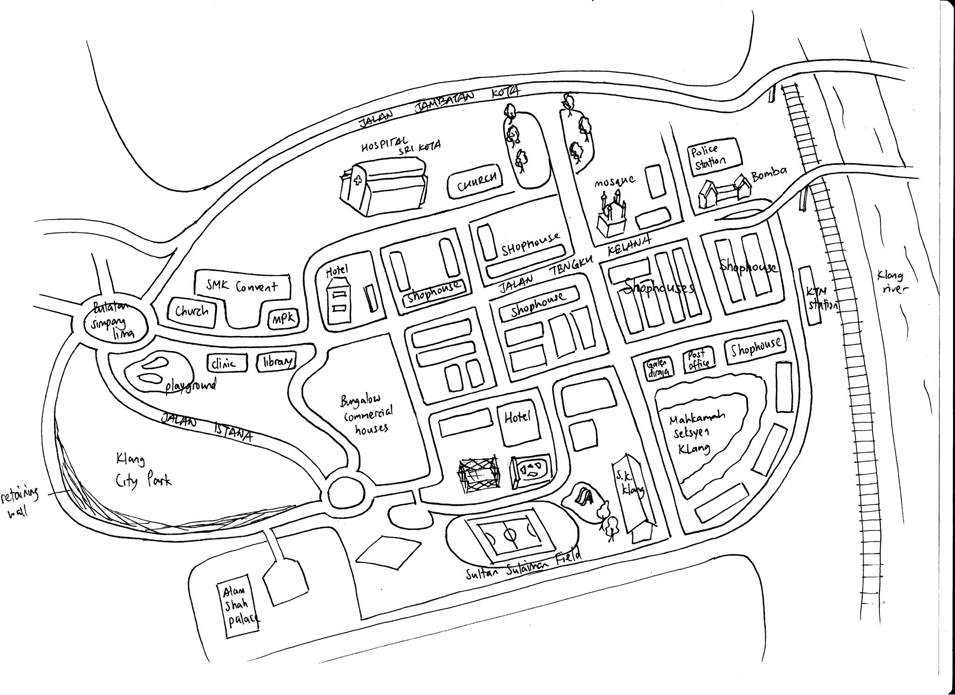

Figure 2 –Cognitive map drawn by Tang Kar Jun (author)

2.0 Pathway Analysis
Based on Kevin Lynch’s theory on The Image of the City & Imageability, the paths are the networks in which the user habitually, occasionally or perhaps travel on. These paths are used frequently due to the roads it connects to the urban context. Looking at Little India, there are major pathways which show its significance. In addition to that, the pathway for both human and vehicular movement shows how busy the Little India street is. 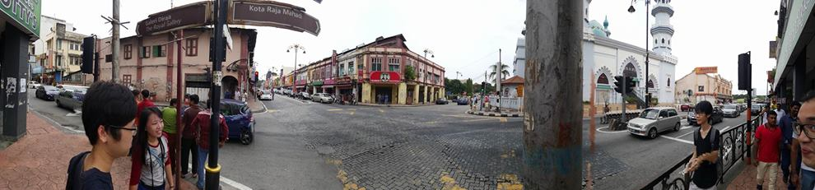
Figure 3 –Jalan Tengku Kelana, Klang (Kar Jun, 2016)
The image above shows the main street of Little India where many occurrences can be found there. While the image may not show a busy street as it was taken on a weekend, I assure you that this city street is extremely busy. Being Little India’s centre street, many of the landmarks can also be noted here such as the Masjid India Klang and as well as the newly built Mydin at the far end of the road. Along this road are the commercial districts whereby the Indian community sell off their many items. Jalan Tengku Kelana is Little India’s most vibrant and busy pathway with inconsistent building height and shape.
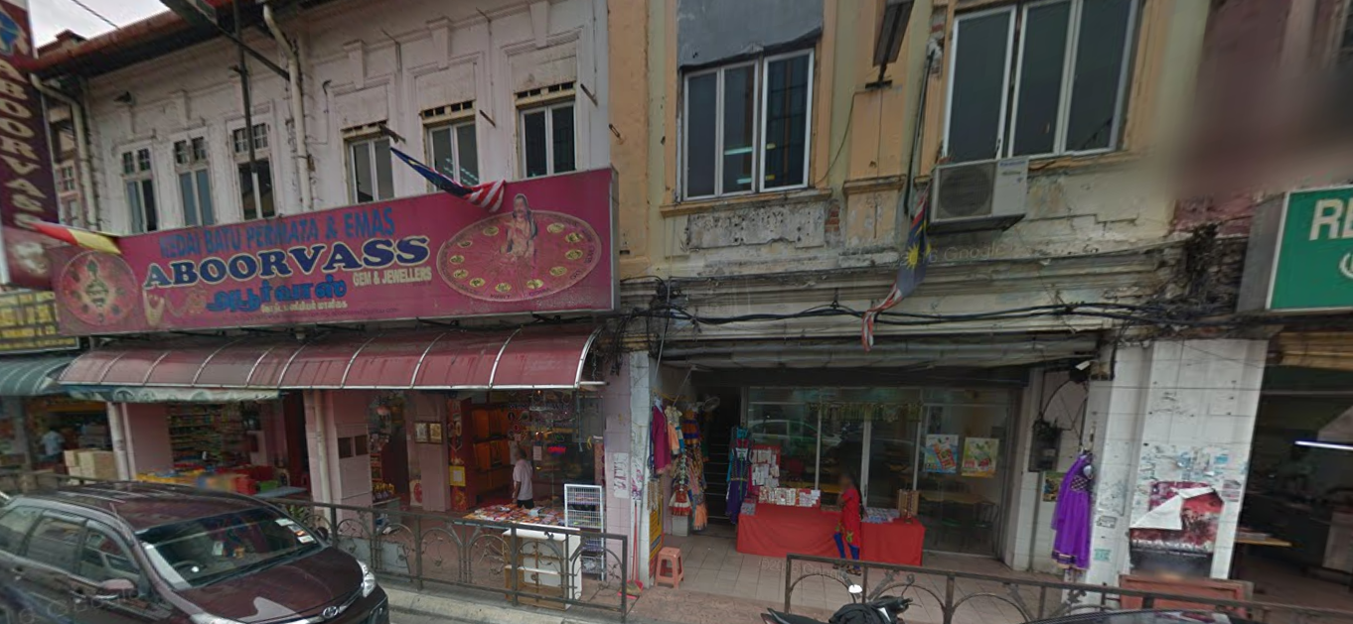
Figure 4 –Walkway at Jalan Tengku Kelana, Klang (Kar Jun, 2016)
Along Jalan Tengku Kelana are busy shophouses which have many of their goods displayed all along the frontage. This makes the human movement difficult but it is part of the lifestyle there. Just by walking down that street, one can grasp their culture through visual and even auditory as there are many Indian ornaments as well as Indian music playing from most shops. It was a really memorable trip due to its busy and loud street. Not to mention, the smell from the spices fill the streets and stimulate one’s sense of smell.
In Little India, therein exists other pathways which shows prominent characteristics which are exclusive to the path itself. For example, Jalan Istana is a pathway filled with greenery and then the Istana is camouflage within the nature.
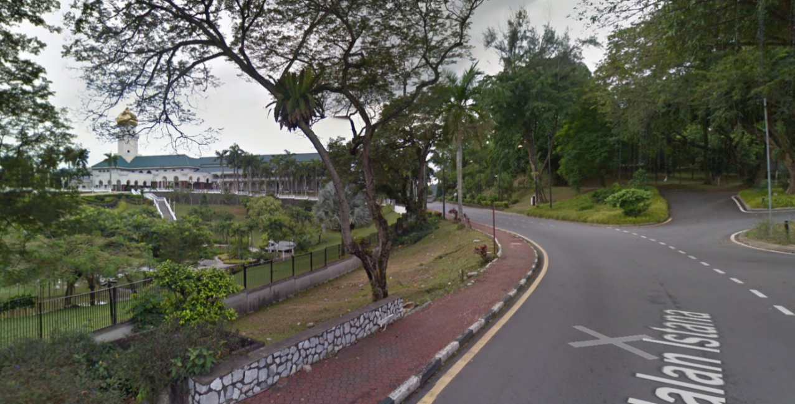
Figure 5 – Jalan Istana Alam Shah (Google Maps, 2015)
There is also Jalan Mohet which house the more advanced communal building on both sides of its street. This has separated this pathway as one where it serves a commercial function. There are service buildings which range from travelling agencies to hospitals which helps the community here in maintaining a productive lifestyle.
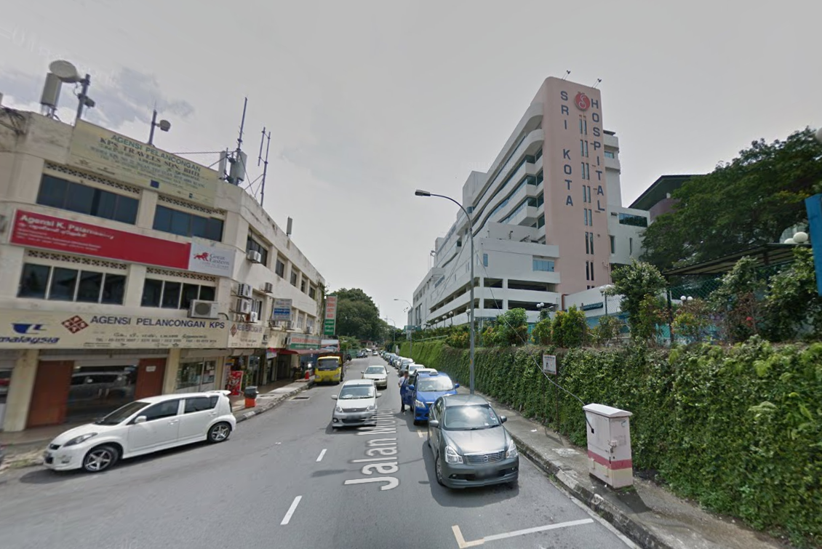
Figure 6 – Jalan Mohet (Google Maps, 2015)
Clear paths that have strong identities will be able to bring a city together. According to Lynch’s theory, if the qualities shown are consistent along the line, the path will be imaged as a continuous, unified element.

3.0 Edges Analysis
Next, the edges are linear elements which make up a boundary between two areas. Edges are usually pathways but they are not necessarily one. Edges can take form from all sorts of pathways depending on its function.
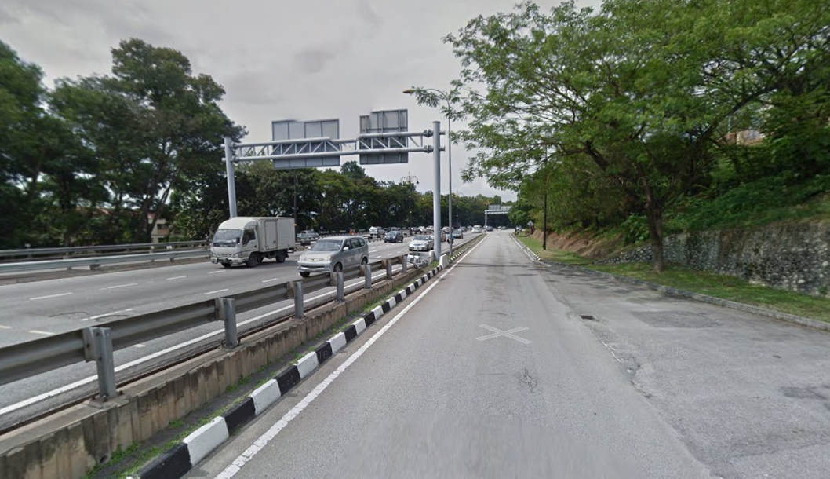
Figure 7 – Highway as an edge (Google Maps, 2015)
Take the above image as reference, that is an intangible edge which separates the highway and our site boundary. It is due to the difference in the road functions which separates the two roads. In Little India, there are also roads from the depots used back then which has been converted into our KL Sentral Stations. The railway tracks for those type of transport also covers the right side of our site boundary and therefore makes up an edge to the site. The tracks are also covered by fences to protect from any accidents and makes an edge very bold. There are also authority edges in which an authority area forms a borderline which separates Jalan Klang from the community districts. This sort of edges may be hard to discover as only a handful of building in the district serve as community service. In Little India, the communal service district actually divides the business districts and authority districts. A different kind of edge is Jalan Istana which has lush greenery to split itself from the regular housing districts.
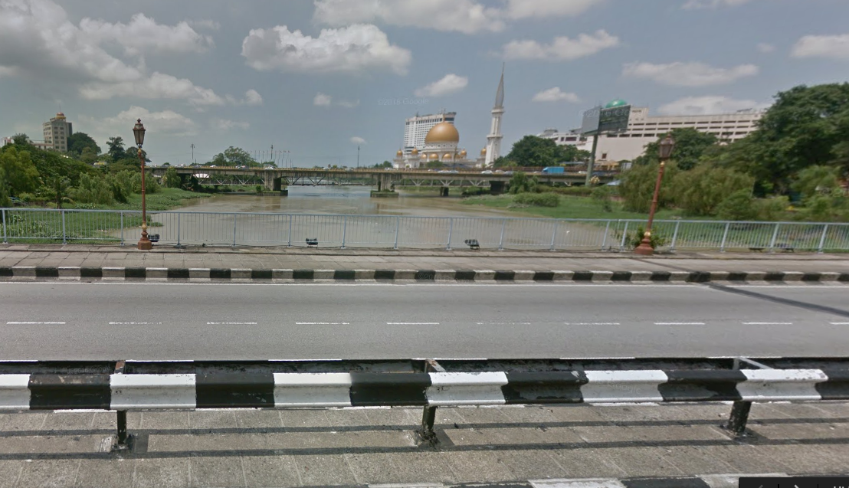
Figure 8 – Klang river from Jalan Tengku Kelana Bridge (Google Maps, 2015)
The Klang river acts as an edge which divides Little India and Klang town. The bridge connects Jalan Tengku Kelana with Jalan Jambatan Kota.

4.0 Districts Analysis
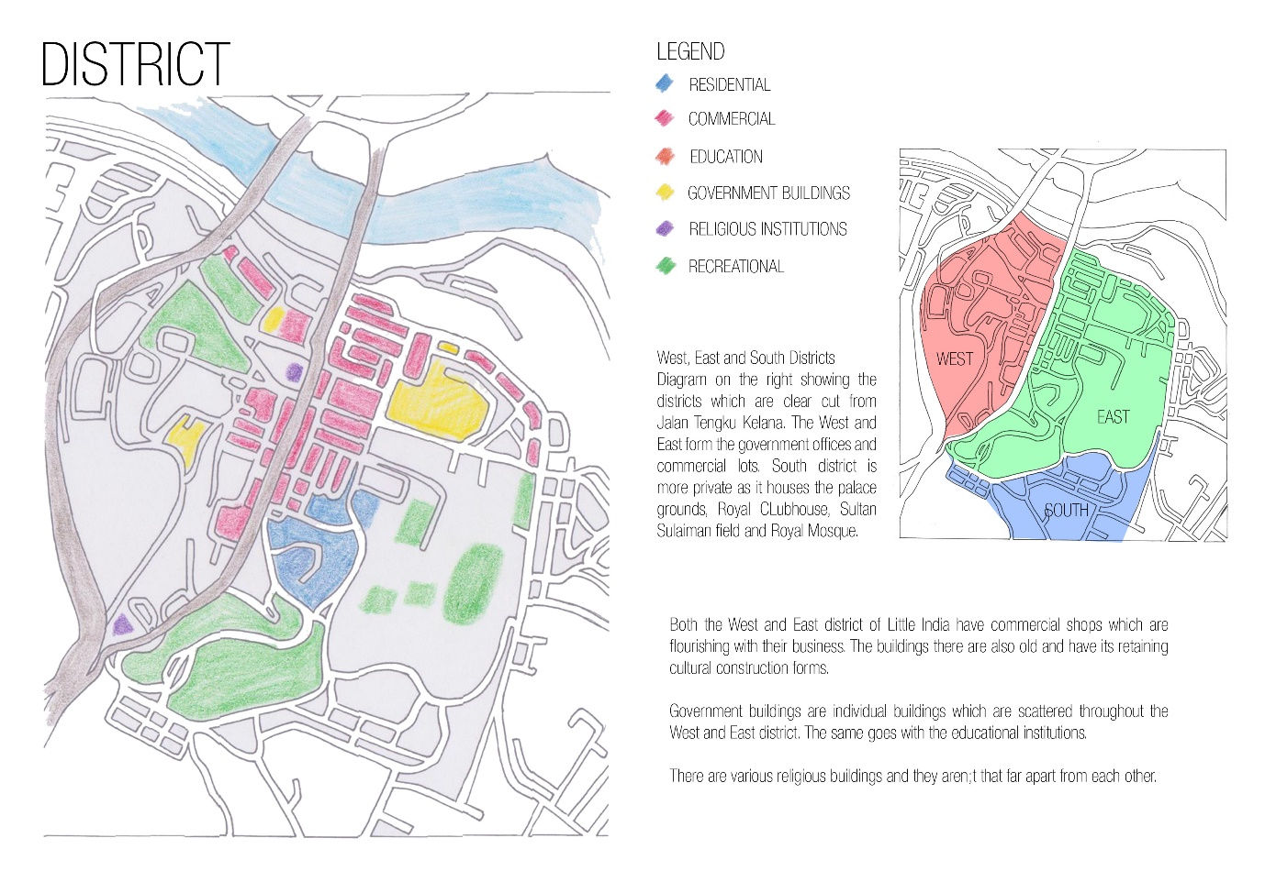
Figure 9 – Districts
Districts are areas of a city whereby the observer can mentally enter which have some common character. The Little India street has morphed a lot since the British colonial times and is now a district selling lots of Indian merchandises and cuisines. Till now, the district has been a huge tourist attraction. By walking down the street now, one can observe the colourful and richness of Indian culture compared to the other districts. Just by the influence of Indian culture, the Little India district has made itself recognized.
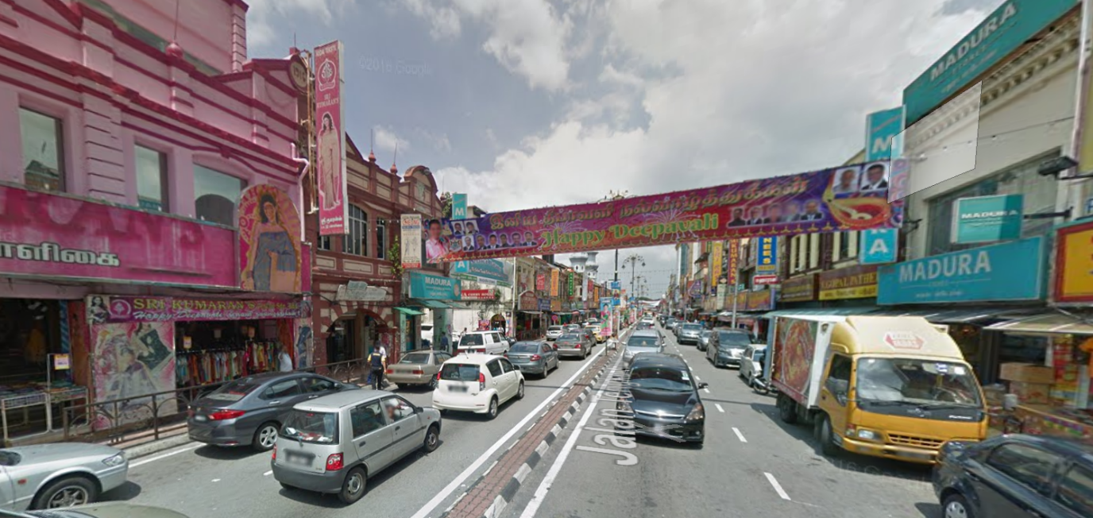
Figure 10 – Indian influence at Jalan Tengku Kelana (Google Earth, 2015)

5.0 Nodes Analysis
Regarding the previous statement, nodes are the strategic focus in a junction or pathway. Being a node in that location must call out the shops’ prominence or even a node for a road constantly having traffic. A node is defined characteristically and is not limited to only shop houses but can also represent road nodes and human nodes. Take Little India’s Jalan Tengku Kelana as an example, the road itself has a few node points whereby the junctions intersect with each other. On top of that, there are also schools located around it.
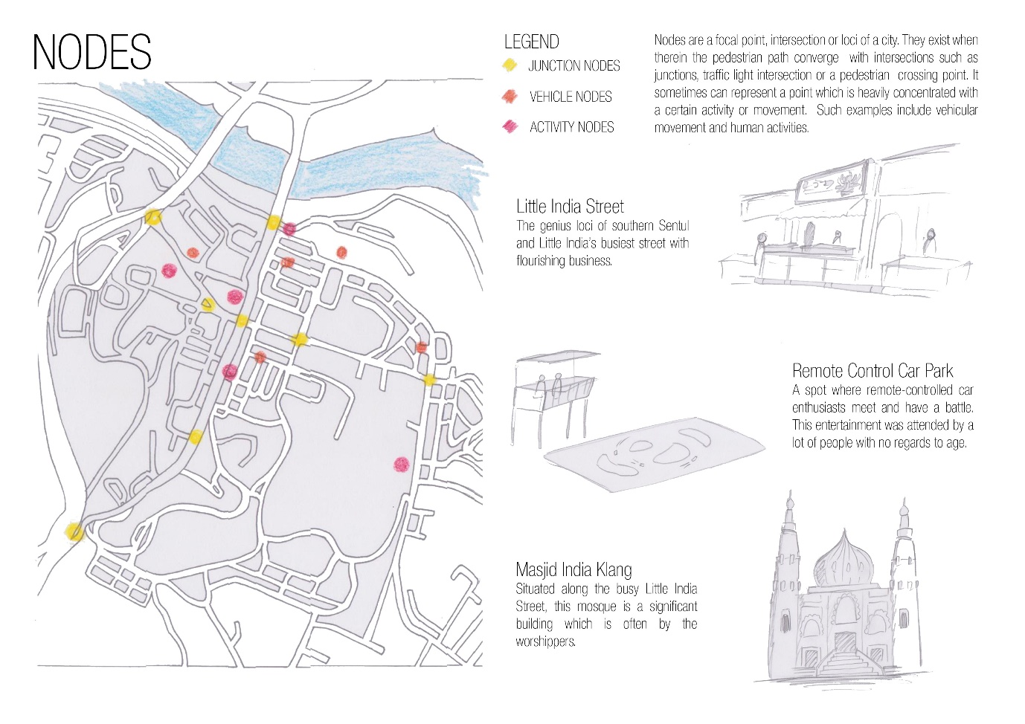
Figure 11 - Nodes
By looking at the above image, Little India is identified to have around three major nodes which is classified into junction nodes, vehicle nodes and activity nodes. Junction nodes are represented by the yellow indicator and is the part of intersection between the roads. These nodes are usually heavy with vehicle traffic at peak hours of the day. Vehicle nodes point to the locations where traffic jams occur due to the end of school hours or even regular traffic.
Lastly are activity nodes which pinpoint the locations where any events are held. There is the Masjid India Klang which the worshippers would frequent to pray at. The KTM is also one such node whereby they take the train to and from other locations. The Royal Klang Club and the Stadium Padang Sultan Sulaiman are seasonal activity nodes whenever a sports event is held. However, during its offdays, it’s a place for recreational purposes. There is also a race circuit for miniature race car models which is an event exclusive to Little India’s community.

6.0 Landmarks Analysis
In little India, there are buildings which are really significant and are considered to any observer to be a referral point. These landmarks are what makes a location really unique as it distances itself as a singularity in a spatial location. In Little India, the landmarks stand out as it contrasts from the surrounding buildings.
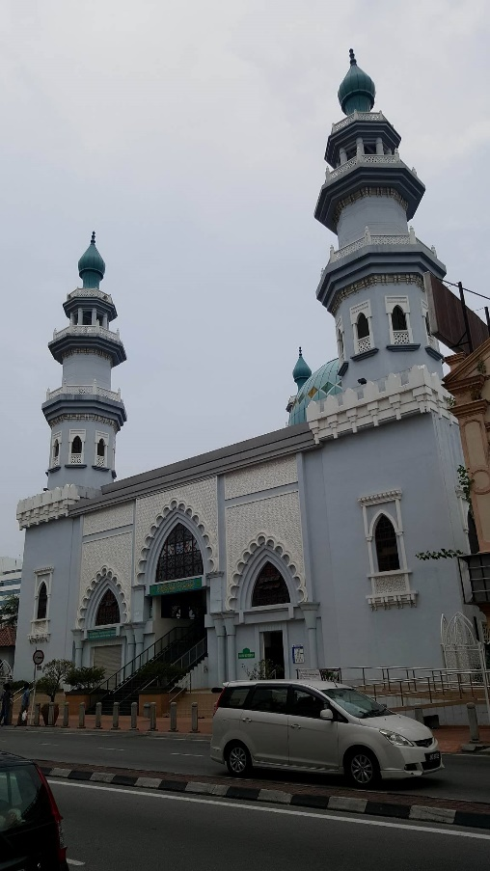

Figure 12 – Masjid India Klang (Kar Jun, 2016)
Masjid India Klang is situated at Jalan Tengku Kelana and is a place of worship for the Muslims. This mosque being the only one in the district is a symbol of architecture and its architectural designs can be found scattered in the vicinity. The mosque is a great landmark due to its functionality and how it stands out.

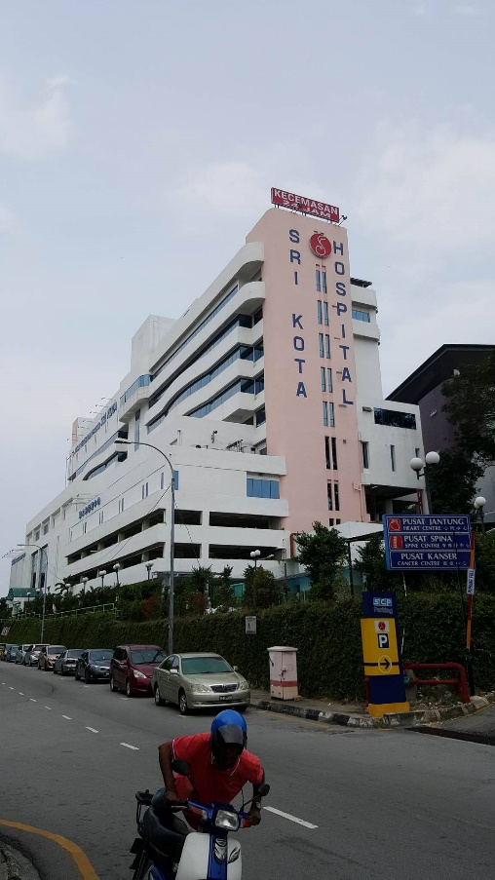
Figure 13 – Hospital Sri Kota (Kar Jun, 2016)
Hospital Sri Kota being the biggest hospital in the district is a huge landmark due to its importance and is located on a slope hill. The building is of great value to the people of Little India as it saves their lives.

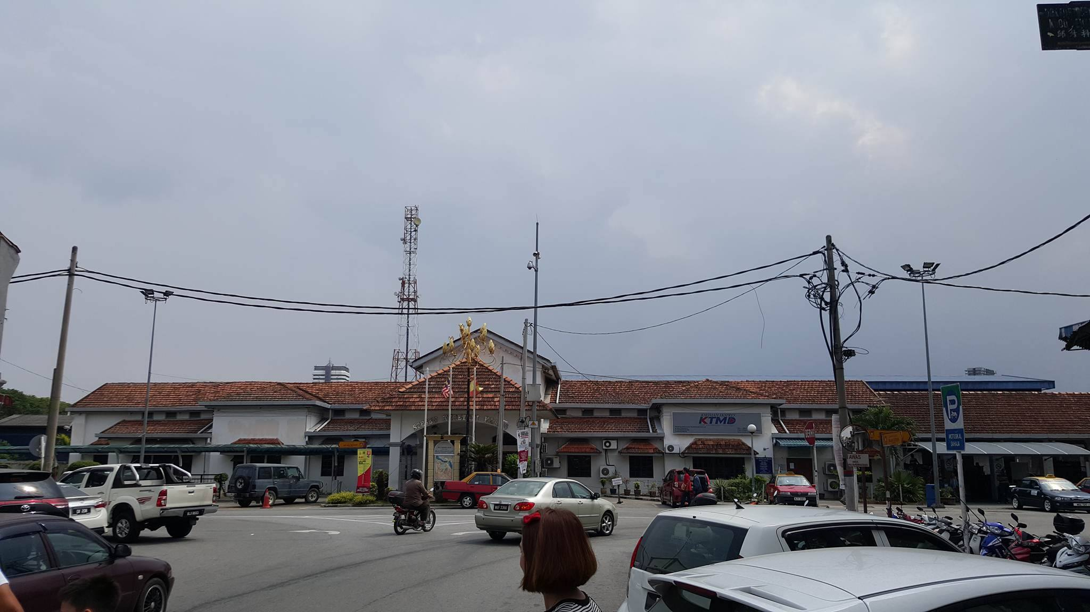
Figure 14 – KTM (Kar Jun, 2016)
Klang KTM railway station is also an important transportation hub whereby it brings the community in and out of Little India. The building itself is unique because of its difference to the colonial shophouses.

7.0 References
Gehl, J. (2011). Life between buildings: using public spae. Island Press
Lynch, K. (1960). The image of The City. Cambridge, Mass.: MIT Press
Mpklang.gov.my. (2016). Official Portal Klang Municipal Council.
Available at http://www.mpklang.gov.my/ms/pelawat/info-klang [Accessed 3 June. 2016]

